The Create Patient Demographic function enables user to create accounts for new patients with a unique hospital identification number for each patient. For existing patients, it allows user to enter and maintain specific patient demographic details such as patient identification, health insurance, contact information, allergies, and referral. User can enter new patient information in the Create Patient Demographic dialog box.

On registering a new patient, a unique patient number (UPN) is created for the patient. UPN is retained and used for the patient’s subsequent visits and consultation.

To avoid creating duplicate accounts for the patient, it is recommended that the user first search for the patient in the clinic database before creating a new account.

Search whether the patient exits or not, if exists then go to the patient’s record and if the patient does not exists then create a new demography.

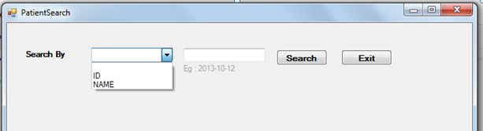

Figure : Search Dialog box

1. To search a patient, user need to select search type in Search By- combo box. Search can be by Patient ID no. or by Name.
   1. Select ID or Name
   2. Enter patient ID no. or Name in search text box
   3. Click Search, then the list of existing patient will be retrieved and can be viewed in the Patient Search dialog box.

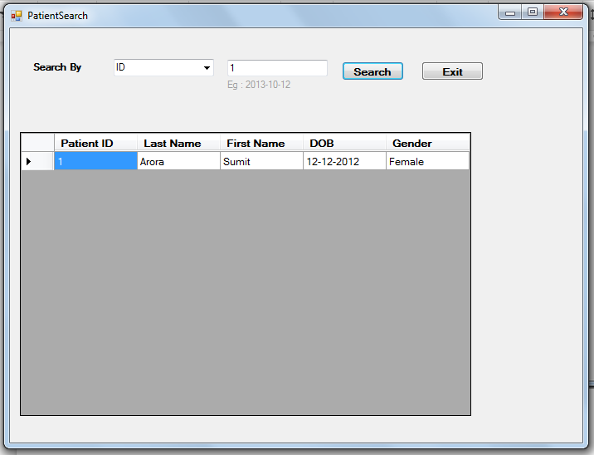

Figure : Search by ID

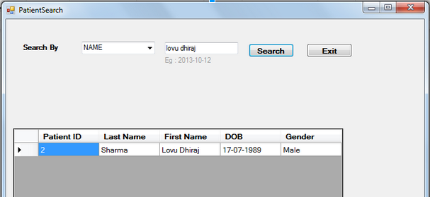

Figure : Search by patient name

If the patient does not exist in the system, a dialog box will be prompted asking “Create New Patient Demography”.

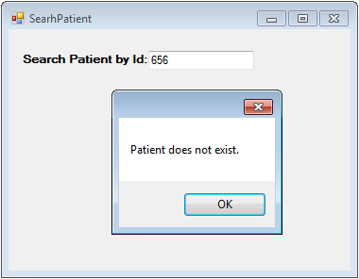

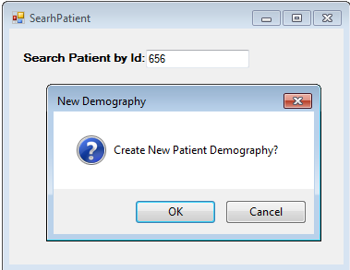

* 1. Click “OK” to create New Patient record. Click “Cancel” to exit.
  2. Create Patient Demographic dialog box will open allowing user to enter demographical data of new patient for registration.

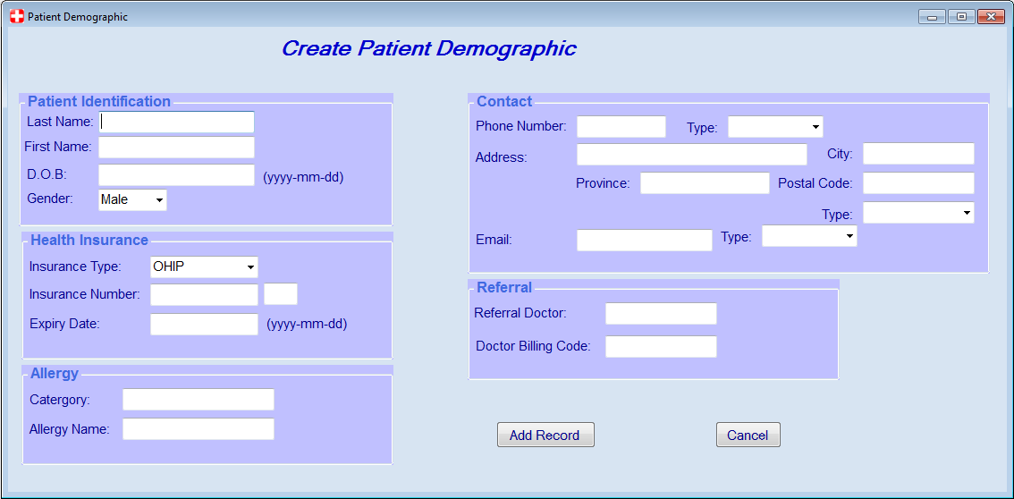

1. In Create Patient Demographic dialog box-Patient Identification text fields, user can enter the following patient demographic information:
   * + 1. Last Name
       2. Firs Name
       3. Date of Birth (DOB)
       4. Gender
2. On the Contact information text box, user can enter the following information:
   * + 1. Phone Number
       2. Home address
       3. Email address
3. On the Health insurance text box, user can indicate:
   * + 1. Insurance coverage type the patient has.
       2. Insurance No. or Policy No.
       3. Expiry date of coverage
4. Under the Allergy text box, user can indicate patient known allergy and its category type.

1. On the referral text box, user can indicate the name of the referring or consulting doctor including the billing code assigned for the patient.
2. After the user completed all mandatory fields and information, user clicks the Add Record button. A dialog box will pop-up and ask if user would like to see View Demography form of the patient just created.